**Introduction**

The proposed development would constitute an enormous departure from the existing Local Planning Schemes and R-Code controls. It does not remotely align with the low-rise character of the neighbourhood as required to be consistent with applicable sections of the Residential Design Codes. It would be like a vertical neighbourhood in low-density surrounds, completely contrary to State Planning Policy Design Principle 1, Context and Character. Blackburne claims there has been community consultation supporting what it proposes, which is patently false. The lack of consultation for a Significant Development is contrary to State Planning Policies.

**Blackburne cannot claim that any community involvement in developing a Local Planning Strategy relates to the proposal because the proposal directly contradicts the position formally adopted by the Town of Cambridge, the very body responsible for the community involvement.**

**Planning and Zoning**

The Ocean Village site is, according to the Town of Cambridge Local Planning Scheme No. 1 publicly gazetted in 1998, a Local (Activity) Centre. The Town of Cambridge lodged Local Planning Scheme No. 2 with the WAPC in August 2023 for advertising approval. Its approval would shift the designation from a Local Centre to a Neighbourhood Centre. Consultation and approval processes in line with State Planning Policies is required before making changes to R-codes, yet this has not occurred.

The Town of Cambridge has not contemplated development beyond R-Code controls applicable to a Neighbourhood Centre in its local planning, as evidenced by Local Planning Scheme No. 1 and the application for Local Planning Scheme No. 2.

**Community Involvement**

In direct communication with me, Mr Paul Blackburne claimed there have been years of consultation on Ocean Village, mostly by the Town of Cambridge related to the Local Planning Strategy. This is nonsensical. Blackburne cannot claim that any community involvement in developing a Local Planning Strategy relates to the proposal because the proposal directly contradicts the position formally adopted by the Town of Cambridge, the very body responsible for the community involvement.

Moreover, there was very little community engagement focusing *specifically* to Ocean Village at all, contrary to Mr Blackburne’s assertion. Only pieces of information of any relevance were presented at Town meetings and formal input was limited to selecting from pre-defined options in a Town of Cambridge survey. Just 23% of Town of Cambridge residents surveyed in March 2024 indicated support for **one** high-rise. Residents have now been presented with a fully-formed proposal for a development which includes one super high-rise (ABS classification) and a *second* high-rise building. There was no information regarding a proposed development of this scale and form, much less transparent consultation.

Blackburne’s justification for the scale of the proposed development appears to rely heavily on a target number of dwellings mentioned in broader planning. However, the long-term target number of 200 to 250 applies to a larger area of land, 1.87 hectares, that includes Kilpa Court residences and a Church (p.21 of Appendix 1 for the Local Planning Strategy).

Relevant to consultation, the target of 200 to 250 additional dwellings is a government set target. Blackburne certainly cannot claim the target *itself* is based on consultation. The community may or may not accept the target, but it is not a product of consultation.

Blackburne refers on its own website oceanvillage.com.au to developing a neighbourhood precinct, not a Neighbourhood Centre. If Blackburne wishes to propose a development of such scale and complexity, it must surely bear the onus of demonstrating the requisite community engagement and consultation. Regarding Blackburne's proposal specifically, the lack of engagement with nearby residents and businesses appropriate to the scale of the development is contrary to IAP2 principles. For example, there was no early and continuous engagement, nor were there any information days, workshops, focus groups, community reference groups, surveys, or other methods as outlined in SPP 7.2, s2.4.3.

**Context and Character**

The overall bulk and scale of development is not remotely appropriate for the existing or planned character of the area, as required in accordance with R-Codes V2, O 2.5.1. This development would be akin to placing a section of the inner city in the middle of a neighbourhood with low density and low-rise buildings.

The scale and height of this development completely disregard the existing context of the surrounding neighbourhood, including that of adjoining buildings, the topography and elevation of site, the general pattern of heights in the area, and views. The proposed development is clearly contrary to maintaining coherent local identity. In all these respects this development is contrary to SPP (SPP) 7 Design Principle 1, Context and Character. Appendix A contains a depiction showing just how incongruous it would be with its surrounds, which has been shared with residents via social media.

The development is not consistent with a Local Centre or Neighbourhood Centre in terms of typical urban form, density, or preferred residential dwelling types, all of which are referred to in SPP 4.2.

The height of the proposed development does not at all respond to the desired future scale and character of the local area, including existing buildings unlikely to change, and is therefore inconsistent with R-Codes V2, O 2.2.1. The desired scale and character are evident in the Town of Cambridge planning documents, including but not limited to Local Planning Scheme Nos. 1 and 2.

The elevation of the tallest structure proposed is 116m, approximately 36m higher than Rendezvous Hotel. On a very elevated site 600m from the sand dunes, there is an obvious incentive for the developer to maximize profit rather than develop based on local and broader planning and needs, as evidenced by the prices of apartments on the Gold Coast with expansive views, and the reaction of local government[1].

**Privacy**

The height, orientation and design of the buildings mean that windows and balconies will directly overlook habitable rooms and private outdoor living areas of neighbouring properties. This can be verified by viewing from Google Earth at relevant elevations, from around 65m up to 115m above sea level, which have been shared with the local community via social media. Consequently, the proposed development is contrary to SPP 7.3 R-Codes V2, O3.5.1. Providing a point of reference, the mobile tower on the site has a height of approximately 65m above sea level with line of sight to significant portions of City Beach and Wembley Downs.

Many storeys of the proposed development would overlook adjacent and nearby properties in every direction. It would loom over the adjacent lots and surrounding area.

**Traffic**

As a Local Centre in the current Local Planning Scheme, the area has limited public transport options, and the proposed development could significantly increase local traffic. The need for waste removal and access by commercial vehicles could exacerbate this situation. I am not aware of any planning for traffic increases associated with the planned development, in accordance with SPP 1. We have therefore not been consulted on any such impact on our lives, in keeping with SPP 7.2 s2.

**Noise**

As a nearby resident who uses the parkland, I am also concerned about the additional mechanical and other noise that a development of this scale will bring, which will disrupt the quiet and peaceful environment of the area.

**Environmental**

I also have concerns about how artificial light, new plant species, changes in local hydrology, and digging associated with significant construction will impact the surrounding A-grade reserve park and bushland, as well as the adjoining properties on the south and west boundaries.

**Support for Joint Submission**

I support “The Joint submission of Shearwater Mews and Sandpiper Mews**”**.

**Flaws in submission**

I am aware from a community member who is providing a highly detailed submission that there are factual flaws in the plan by the developer and request the proposal is carefully scrutinised for factual errors.

**Concluding Remarks**

I moved back into City Beach in 2021 after more than 30 years, when I purchased a home in Maloney Way that my parents built as owner-builders. In purchasing property in the area, we could not possibly have imagined a super high-rise structure would be proposed on the Ocean Village site. The site is zoned as a Local Centre in the Local Planning Scheme and in Landgate documentation. I welcome development on the site, but it must be the result of orderly planning with proper community involvement in line with State Planning Policies and Design Principles. We pay rates to the Town of Cambridge to manage and maintain communal property and public services and for associated local planning. I earnestly request that the State Government upholds the principles of procedural fairness by respecting Local Planning processes and allowing these to continue until a fair and just outcome is achieved.

**Appendix**

The image depicts the proposed structures in context, approximately to scale. The elevation of the GoogleEarth image is 116m and the top of the tallest structure aligns with the horizon.

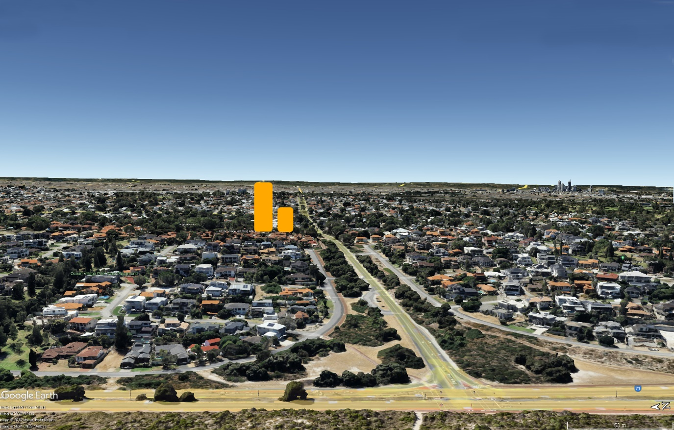

1. https://www.abc.net.au/news/2024-07-25/gold-coast-high-rise-rates-increase-by-apartment-level/104139574